

SQL Views – Research & Implementation Task

Ebtesam obaid nasser alzaabi

Part 1: Research & Documentation
Types of Views in SQL Server :
Type | Standard View | Indexed View | Union View
What is it? | is a virtual table created using a SELECT statement. It does not store data physically . | that stores data physically after a unique clustered index is created on it. | A Partitioned View combines data from multiple tables using UNION ALL. Each table holds a portion of the data, often split by date or range.
Key differences | · No physical storage (unlike Indexed View).  · No indexing on the view itself.  · Simple to create and maintain.  · Query is executed every time the view is used. | Data is stored on disk  Requires WITH SCHEMABINDING  Faster query performance for aggregations  Slower DML operations on base tables | Data remains in multiple tables  Used for horizontal partitioning  Improves manageability rather than raw performance  Requires identical table structures
Real-life use cases | 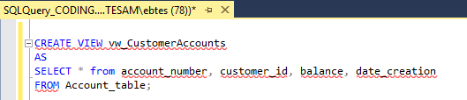 | 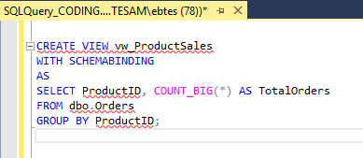 | 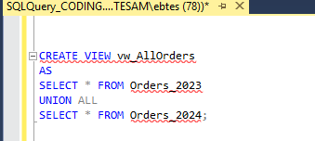
Limitations and performance | * Slower for complex queries on large tables  * Performance depends entirely on base table indexes  *Cannot significantly improve query speed  * Complex standard views may not be datable | Extra storage required  INSERT/UPDATE/DELETE operations become slower  Many restrictions (no SELECT *JOIN functions)  Best suited for read-heavy systems | •All tables must have the same schema  • Queries can be slower if partitions are not properly filtered  • Requires CHECK constraints for partition elimination  • Maintenance complexity increases with many tables

- Can We Use DML (INSERT, UPDATE, DELETE) on Views?

Yes, but not all views allow DML operations.
Whether DML is allowed depends on the type of view and how it is defined.

Which Types of Views Allow DML Operations?

Standard Views
DML Allowed: INSERT, UPDATE and DELETE
View must reference only one base table and contain no complex clauses.

Indexed Views
DML Allowed: Direct DML on the view is NOT allowed
You modify the base tables, not the indexed view.
SQL Server automatically updates the indexed view internally.

Partitioned Views
DML Allowed: Limited
INSERT is allowed only if SQL Server can determine the correct base table.
Requires CHECK constraints on base tables.
UPDATE or DELETE may fail if row mapping is unclear.
--
Restrictions & Limitations When Performing DML on Views
A view is NOT updatable if it contains: GROUP By - Aggregate functions (SUM, COUNT, etc.)
DML Rules for Views you should:
- Must reference only one base table
- All NOT NULL columns without defaults must be included
- Columns being modified must come directly from the base table
- No ambiguity in row identification

one real-life example
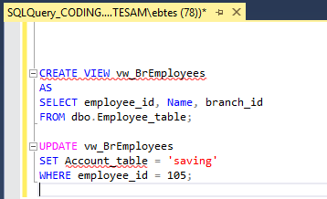

- How Can Views Simplify Complex Queries?

Data is normalized across many tables Queries often require multiple JOIN
The same long query gets repeated by:
- Reports
- Applications
- Support teams

Part 2: Real-Life Implementation Task (Banking System):
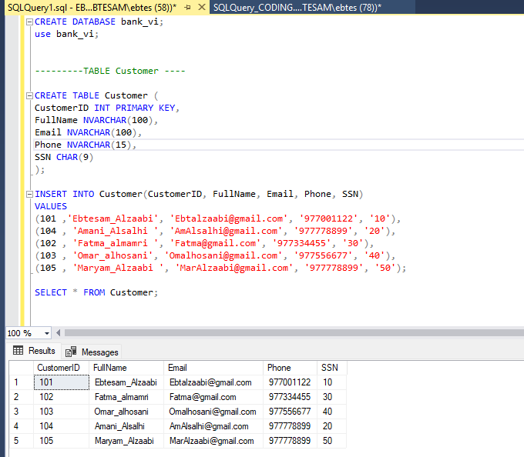
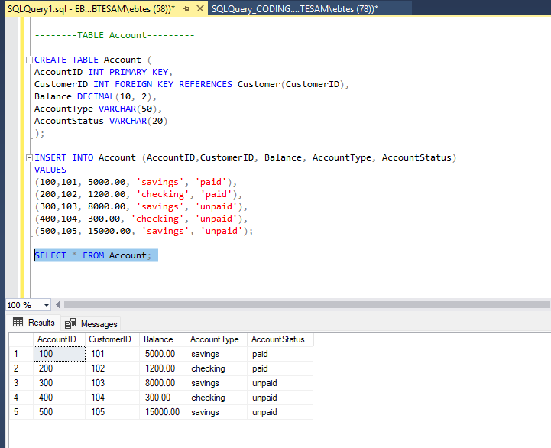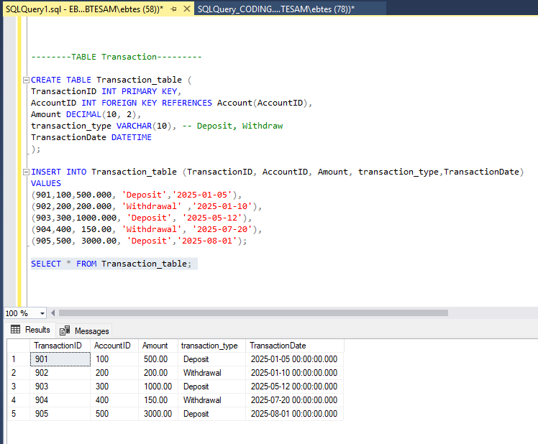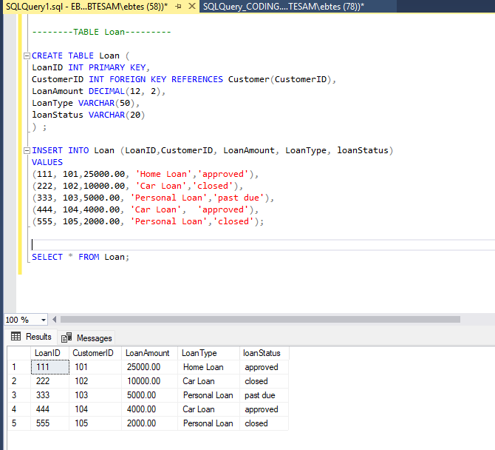

Part 3: View Creation Scenarios
- Customer Service View
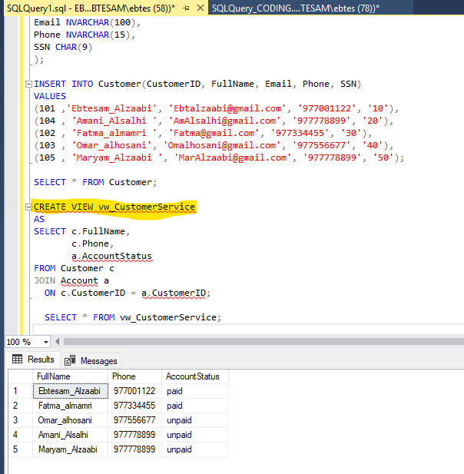

- Finance Department View
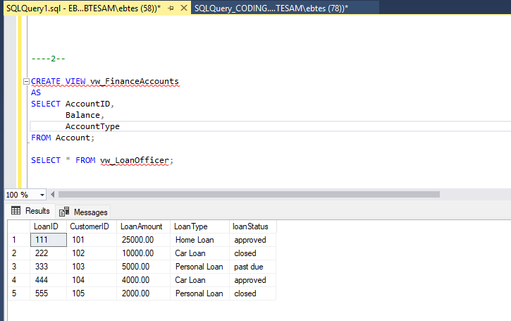

- Loan Officer View
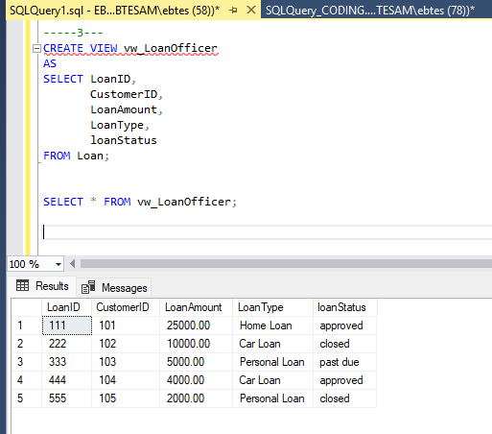

- Transaction Summary View
